Activity 3
System Design and Development

3.1 Introduction
The AI-Powered Assistive Tool for Early Diagnosis of Diabetic project adopts the Incremental Model of Software Development Life Cycle (SDLC). This model is well-suited for developing healthcare-related applications as it allows building core diagnostic features first and progressively integrating advanced AI capabilities, wearable integration, and user interfaces.

3.2 Description of the Incremental Model
The Incremental Model structures development into multiple cycles (increments), each delivering a working module. For this healthcare tool, core functionalities like patient data intake and risk scoring are built first, followed by AI-model integration, report generation, and real-time patient feedback modules.

3.3 Phases of the Incremental Model
- Requirement Analysis
Identify medical data inputs, diagnostic goals, and patient safety considerations.
- System Design
Architect a scalable system with modules for data collection, ML inference, and report generation.
- Implementation & Coding
Implement modules in increments – starting with user registration and progressing to AI diagnosis.
- Testing
Each increment is tested for medical accuracy, data privacy, and reliability.
- Integration & Deployment
Gradually deploy core features followed by enhanced modules like smart alerts and trend analysis.
- Maintenance & Enhancement
Patient feedback, clinician input, and new medical standards inform system updates.

3.4 Justification for Using the Incremental Model

✅ Early Deployment of Core Diagnostic Capabilities
- Quickly provide basic risk assessment tools for diabetic symptoms.

✅ Reduced Risk
- Medical risks are minimized by validating small modules at each stage.

✅ Flexibility
- Supports future integration of advanced AI models or wearable devices (e.g., CGM, smartwatches).

✅ Efficient Resource Allocation
- Development teams can work on frontend, backend, and model training in parallel.

✅ User Feedback Integration
- Real-world doctor and patient feedback improves clinical usability and accuracy.

3.5 Alternative Consideration: Agile Model
Agile is ideal for iterative feedback but may lack structure for a healthcare environment needing robust documentation. In academic and compliance-focused domains, Incremental is preferred due to its clarity and traceability.

3.6 Use Case Diagram
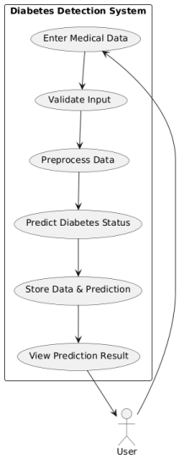

3.7 Data Flow Diagram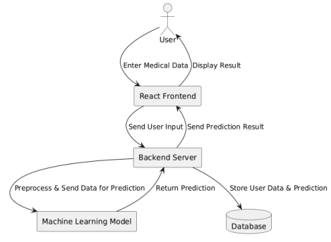

3.8 Class Diagram

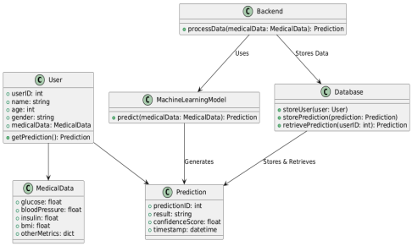

3.9 Sample Output Interface

✅ Login Interface

✅ Patient Dashboard

✅ Diagnosis Result Page

3.10 Conclusion
The Incremental Model is the optimal choice for this AI-powered healthcare tool because:
- 🟩 Core features are developed and released early.
- 🟩 It minimizes medical risk via gradual testing.
- 🟩 Enhancements (like real-time monitoring and predictive analytics) can be integrated later.
- 🟩 Encourages collaborative improvements based on medical expert feedback.

